

|  |
| --- |
| CUSTOMER EXPERIENCE PREDICTION |



|  |  |  |
| --- | --- | --- |
| DATE | DESCRIPTION | AUTHOR |
| 25-06-2023 | HLD- Version 1.0 | SHREYASH VIRENDRA CHAWDA |

⦁ Introduction

Machine Learning Project for predicting customer experiences in using telecom service. This helps the Telco’s operator to target customer and try to give better service and increase their network in Telecommunication. This prediction will help to compete with many Internet based service and also with OTT platform.

⦁ Why this High-Level Design Document?

The purpose of this High-Level Design (HLD) Document is to add the necessary detail to the current project description to represent a suitable model for coding. This document is also intended to help detect contradictions prior to coding, and can be used as a reference manual for how the modules interact at a high level.

The HLD will:

⦁ Present all of the design aspects and define them in detail

⦁ Describe the user interface being implemented

⦁ Describe the hardware and software interfaces

⦁ Describe the performance requirements

⦁ Include design features and the architecture of the project

⦁ List and describe the non-functional attributes like: Security

⦁ Reliability

⦁ Maintainability

⦁ Portability

⦁ Reusability

⦁ Application compatibility

⦁ Resource utilization

⦁ Serviceability

⦁ Scope

The HLD documentation presents the structure of the system application architecture (layers), application flow (Navigation), and technology architecture. The HLD uses non-technical to mildly-technical terms which should be understandable to the administrators of the system.

⦁ Product Perspective

The customer experience prediction is Machine Learning based model in which it’s predicting customer who are still churning Telco’s service.

⦁ Problem statement

Globally, the number of mobile-cellular subscriptions is approaching the number of people on the planet, with emerging countries accounting for more than three-quarters of the total. GPS navigation, voice and text over data, and social media exchanges are just a few instances of how we are becoming increasingly reliant on our mobile phones. We expect to be online at all times because our business and personal lives would be disrupted if we weren't. Telecommunications operators (Telcos) are struggling to match these high expectations in a market where traditional phone and text plans are being phased out in favor of data offerings that support a wide range of mobile apps. For telcos, having a clear, up-to-date understanding of customer experience and satisfaction is a critical competitive advantage. Telcos, on the other hand, face the issue of coping with massive amounts of data created by mobile consumers every second.

⦁ PROPOSED SOLUTION

The customer experience regarding service of telecom operators is recognize and predicting the number of customers which are churning the telcos services which will help the operators to target that customers also gets more insight to increase their product and come up with more flexible service which will attract more customers.

⦁ FURTHER IMPROVEMENTS

Customer Experience Prediction project will need more insight of customers’ demands and different attractive services which will help to attract more customers. Model needs more data with more different parameters like feedback, comments etc. which can be used with the help of sentiments analysis to train model with will give more good result.

⦁ Data

Dataset contains csv file with 7043 rows and 21 columns in which 20 independent features and one dependent features which is target variable.

**Data Features Info**

1. customer ID-->Unique id of customer
2. gender-->male/female
3. Senior Citizen-->Yes-1 No-0
4. Partner-->Whether the customer has a partner or not (Yes, No)
5. Dependents-->Whether the customer has dependents or not (Yes, No)
6. tenure-->Number of months the customer has stayed with the company
7. Phone Service-->Whether the customer has a phone service or not (Yes, No)
8. Multiple Lines-->Whether the customer has multiple lines or not (Yes, No, No phone service)
9. Internet Service-->Customer’s internet service provider (DSL, Fiber optic, No)
10. Online Security-->Whether the customer has online security or not (Yes, No, No internet service)
11. Online Backup — whether the customer has online backup or not (Yes, No, No internet service)
12. Device Protection — whether the customer has device protection or not (Yes, No, No internet service)
13. TechSupport — whether the customer has tech support or not (Yes, No, No internet service)
14. Streaming — whether the customer has streaming TV or not (Yes, No, No internet service)
15. Streaming Movies — whether the customer has streaming movies or not (Yes, No, No internet service)
16. Contract — type of contract according to duration (Month-to-month, One year, Two year)
17. Paperless Billing — bills issued in paperless form (Yes, No)
18. Payment Method — payment method used by customer (Electronic check, Mailed check, Credit card (automatic), Bank transfer (automatic))
19. Monthly Charges — amount of charge for service on monthly bases
20. Total Charges — cumulative charges for service during subscription (tenure) period

⦁ Tools used

1. VS code is used as IDE.
2. Pandas, Numpy is used for data wrangling.
3. Scikit learn library is used for pipeline and model building.
4. For visualization of the plots, Matplotlib, Seaborn are used.
5. Docker is used for deployment.
6. Front end development is done using HTML.
7. GitHub is used as version control system.

⦁ Design Details

Process Flow

For identifying the different types of anomalies, we will use a machine learning base model. Below is the process flow diagram is as shown below.

Proposed Model

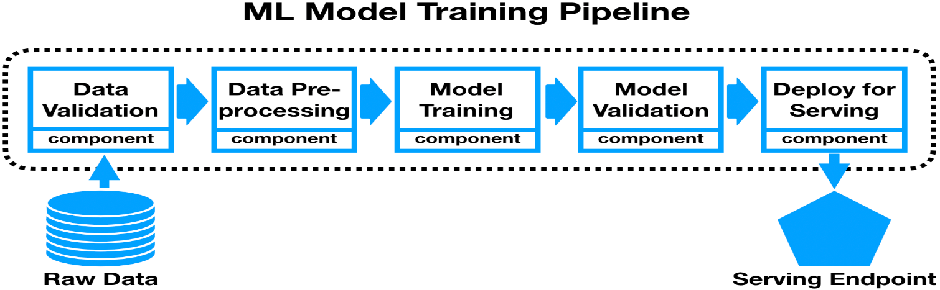

⦁ Model Training and Evaluation

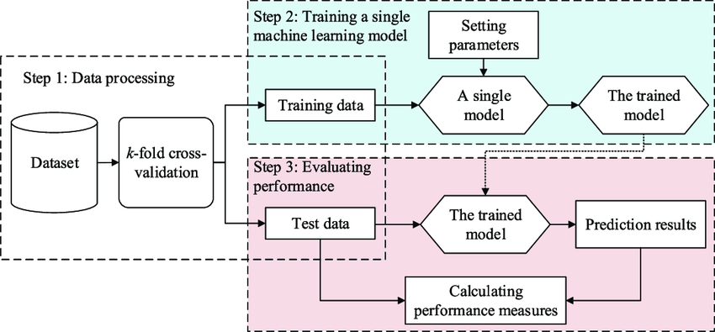

⦁ Model Deployment

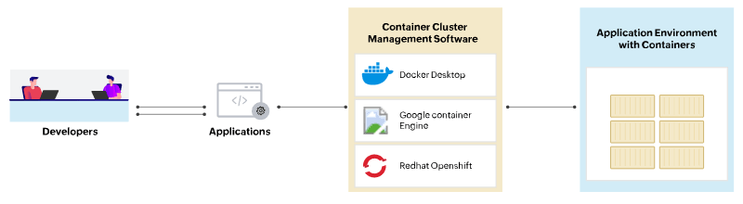

⦁ Event log

The system should log every event so that the user will know what process is running internally.

Initial Step-By-Step Description:

The System identifies at what step logging required

The System should be able to log each and every system flow.

Developer can choose logging method. You can choose database logging/ File logging as well.

System should not hang even after using so many loggings. Logging just because we can easily debug issues so logging is mandatory to do.

⦁ Error Handling

Should errors be encountered, an explanation will be displayed as to what went wrong? An error will be defined as anything that falls outside the normal and intended usage.

⦁ Performance

This model train with classification algorithm which is giving 75% above accuracy. Based on input parameters appropriate data information we will achieve our desired output.

⦁ Reusability

The code written and the components used should have the ability to be reused with no problems.

⦁ Application Compatibility

The different components for this project will be using Python as an interface between them. Each component will have its own task to perform, and it is the job of the Python to ensure proper transfer of information.

⦁ Resource Utilization

When any task is performed, it will likely use all the processing power available until that function is finished.

⦁ KPIs (Key Performance Indicator)

1. Keep the track and predict customers churn in Telcos service.
2. Helps to grow the Telcos industry.
3. Helps in growing businesses by understanding customers.
4. Customers demand and there likes can be analysis and help the Telcos to give better service which will attract more customers
5. Minimize the financial burden to the corporate.